**Faculty Profile**

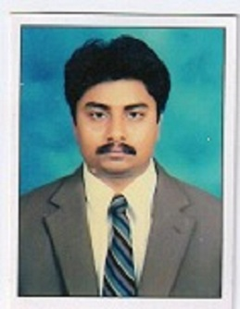

|  |  |
| --- | --- |
| Name &Address | R N RAGHURAM  Lecturer in Computer Science, GDC, Ramachandrapuram |
| Educational Qualifications | M.Sc.(Computer Science) |
| Teaching Experience | 21 years |
| Research Experience | NIL |
| Present Post & Responsibilities held | Lecturer in Computer Science |
| Professional Training Programs attended | 1 |
| Publications in Journals | NIL |
| Paper Presentations in Seminars & Conferences | NIL |
| Workshops/Trainings attended | 6 |
| FDPs attended | 8 |
| National /International Seminars attended | 2 |
| Awards /Honours | NIL |
| Research Guideship | NIL |
| Membership in Professional Organizations | NIL |
| MOOCS Enrolled/Completed | NIL |
| Any other Information | NIL |